MINI PROJECT REPORT
ON
“STUDENT RECORD SYSTEM”
Submitted in partial fulfilment of the requirements for the award of a
degree of
Bachelor of Computer Applications (BCA)
To
UTTARANCHAL SCHOOL OF COMPUTING SCIENCES
UTTARANCHAL UNIVERSITY, DEHRADUN



Under the guidance of Submitted by
Ms. Divya Rawat Ayush Singh (25220800365)
(Assistant Professor ) BCA-II (D)
USCS (Batch: 2025- 2028)

ACKNOWLEDGMENT

The completion of any work is always a rewarding moment, but it is never the result of individual effort alone. It is the outcome of constant support, guidance, and encouragement from many people, and I would like to acknowledge their contribution in making this project possible.
First and foremost, I extend my sincere gratitude to Prof. (Dr.) Sonal Sharma, Director of USCS, for providing such a motivating and positive environment that inspired me throughout my studies.
I am deeply thankful to Prof. (Dr.) Sameer Dev Sharma, Head of Department, USCS, for his encouragement and valuable suggestions. I also owe my heartfelt gratitude to my project mentor, Ms. Divya Rawat, for her patient guidance, constructive feedback, and continuous support at every stage of this project, which greatly strengthened my confidence and learning.

Ayush Singh
Enroll. No. UU2509000119
BCA (2st Sem)
Section-'D'

DECLARATION

I, Ayush Singh, hereby declare that the project work entitled “STUDENT RECORD SYSTEM” submitted for the partial fulfilment of BCA is my original work. I have carried out this project work independently under the guidance of Ms. Divya Rawat, and it has not been submitted to any other institution or organization for the award of any degree or diploma.
I further declare that the information derived from various sources has been duly acknowledged in the report, and no part of this project has been plagiarized or copied without proper citation.

Ayush Singh
Student ID: 25220800365
Enroll. No. UU2509000119

CERTIFICATE OF ORIGINALITY

This is to certify that the project report titled “STUDENT RECORD SYSTEM" submitted by Ayush Singh, Enroll. No. UU2509000119, in partial fulfilment of the requirements for the degree of BCA Data analysis, is a record of original work carried out by her under my supervision and guidance.
The project work was carried out during the academic year 1st and it has not been submitted previously to any other institution or university for the award of any degree or diploma.

Under the guidance of
Ms. Divya Rawat Assistant Professor- USCS
Uttaranchal University Dehradun

Table of Contents

1.Introduction and Objective of the project-------------------------------------------------------6- 7
2.System Analysis :-
2.1 Hardware and software-----------------------------------------------------------------------------8
3.Problem Definition--------------------------------------------------------------------------------9-10
4.Requirement Specification----------------------------------------------------------------------11-12
5.System Design---------------------------------------------------------------------------------------13
5.1 Flow chart------------------------------------------------------------------------------13
5.2 DFD ------------------------------------------------------------------------------------14
6.Code and output---------------------------------------------------------------------------------15-23
8. Testing---------------------------------------------------------------------------------------------24
9.Future Scope of the project------------------------------------------------------------------------25
10.Further Enhancements-----------------------------------------------------------------------------26
11.Bibliography----------------------------------------------------------------------------------------27

Introduction

The STUDENT RECORD SYSTEM is a digital platform designed to help students, working professionals, and parents monitor academic or professional progress easily. In traditional systems, progress reports are usually shared through physical documents or occasional meetings, which may lead to delays, loss of records, and lack of transparency.
This portal provides a secure login-based interface where students and working individuals can view their performance reports, achievements, attendance, and feedback in real time. Parents of students can also log into the system using the student's credentials to monitor their child's academic performance and stay informed about their overall development.
The system also allows users to track their academic records, participation in competitions, certifications, and other extracurricular activities. By storing all this information in a centralized digital database, the portal makes it easier to maintain accurate records and access them whenever needed.
Additionally, the platform provides a user-friendly dashboard that displays important information such as performance statistics, progress summaries, and achievement records. This helps users understand their strengths and areas that need improvement.
By digitizing progress reports, the portal ensures easy accessibility, transparency, data security, and better communication between students, parents, and institutions or organizations. It also reduces paperwork and improves efficiency in managing academic and professional records.

Objectives

- The main objectives of the Online Progress Report Portal are:

Provide easy access to progress reports for students and working professionals anytime and anywhere. Allow parents to monitor their child's academic performance through a secure login system. Maintain a centralized digital record of performance, attendance, and achievements. Reduce paperwork and manual handling of progress reports. Improve transparency between students, parents, teachers, and organizations. Ensure data security by using login IDs and passwords for authorized access. Enable quick updates of performance reports by institutions or organization

System Analysis
HARDWARE AND SOFTWARE USED

HARDWARE USED: -

- Processor intel Core i5 (14 generation)

- Storage 512 Gb SSD

- Mouse
- Laptop
SOFTWARE USED: -

- Windows OS

- Dev c ++

- Vs code

- Operating System Windows 11

Problem Statement

In many educational institutions and workplaces, progress tracking is still done manually through printed reports or periodic meetings. This traditional method creates several problems such as delayed information sharing, difficulty in accessing records, and lack of continuous monitoring by parents or supervisors.

Students and working professionals often do not have a centralized platform to track their performance regularly. Similarly, parents cannot easily monitor their child’s academic progress unless they attend meetings at the institution.

Therefore, there is a need for a secure and user-friendly online portal where progress reports can be stored, updated, and accessed anytime by authorized users such as students, working professionals, and parents.

Definitions

Online Portal
A web-based platform that allows users to access information and services through the internet using login credentials.

User Authentication
A security process that verifies the identity of a user through a username and password before granting access to the system.

Progress Report
A detailed record that shows the performance, achievements, attendance, and feedback of a student or working professional over a specific period.

Login Interface
A digital screen where users enter their username and password to securely access their personal dashboard.

Dashboard
A personalized interface that displays the user’s progress report, updates, and relevant information.

Database
A digital storage system used to store user data, progress reports, login details, and other information.

Requirement Specification
1. Functional Requirements
Functional requirements describe the main functions and operations that the system must perform.
1.1 User Registration
The system should allow students to create an account by entering their basic details such as name, email, password, course, and college name.
1.2 User Login
The system should provide a secure login feature where registered users can access their accounts using their email and password.
1.3 Student Profile Management
The system should allow students to add, update, and manage their personal details including:
- Name
- Course
- College
- Skills
- Interests
1.4 Academic Record Management
The system should allow students to enter and store their academic performance such as:
- Semester marks
- CGPA
- Subject details
1.5 Competition Record
Students should be able to add records of competitions they have participated in, including:
- Competition name
- Date of competition
- Result (Win/Loss/Participation)
1.6 Certificate Upload
The system should allow students to upload and store certificates related to academic achievements and extracurricular activities.
1.7 Dashboard
The system should provide a dashboard that displays:
- Student profile information
- Academic performance
- Competition participation
- Achievements and certificates
2. Non-Functional Requirements
Non-functional requirements describe the quality and performance of the system.
2.1 Performance
The system should load quickly and respond efficiently to user actions.
2.2 Security
User data and login information should be protected using proper authentication and security measures.
2.3 Usability
The system should have a simple and user-friendly interface so that students can easily navigate and use the features.
2.4 Compatibility
The system should work properly on different devices such as mobile phones, laptops, and desktop computers.
2.5 Reliability
The system should store and manage student data accurately without data loss.

FLOW CHART
Start

Open Website
Login Page
Enter Username & Password
Verify Credentials
Valid Login?

NO
YES
Show Error Message
Open Dashboard

Login Again

Add/View Student Records

Calculate Marks
Show Analytics
Store Data in Database
END
DFD
Level 0 DFD
Student Record Management System

Student Details / Requests
Student

Results / Records / Updates

Admin

Level 1 DFD
Student
Registration
Student DB

Record Update
Admin

Academic DB

Student
Report View

CODE
from flask import Flask, render_template, request, redirect, url_for, session
import sqlite3
import os
from werkzeug.utils import secure_filename
from datetime import datetime

app = Flask(__name__)
app.secret_key = "secretkey"

UPLOAD_FOLDER = 'static/uploads'
app.config['UPLOAD_FOLDER'] = UPLOAD_FOLDER
# ---------------- DATABASE INIT ---------------- #
def init_db():
conn = sqlite3.connect('students.db')
cursor = conn.cursor()
# User Table
cursor.execute('''
CREATE TABLE IF NOT EXISTS students (
id INTEGER PRIMARY KEY AUTOINCREMENT,
username TEXT UNIQUE,
password TEXT
)
''')

# Student Records Table
cursor.execute('''
CREATE TABLE IF NOT EXISTS student_records (
id INTEGER PRIMARY KEY AUTOINCREMENT,
name TEXT,
roll_no TEXT,
course TEXT,
year TEXT,
sub1 INTEGER,
sub2 INTEGER,
sub3 INTEGER,
total INTEGER,
percentage REAL,
cgpa REAL,
grade TEXT
)
''')

# Achievements Table (NEW)
cursor.execute('''
CREATE TABLE IF NOT EXISTS achievements (
id INTEGER PRIMARY KEY AUTOINCREMENT,
student_id INTEGER,
title TEXT,
filename TEXT,
FOREIGN KEY(student_id) REFERENCES student_records(id)
)
''')

# Default Login
cursor.execute("INSERT OR IGNORE INTO students (id, username, password) VALUES (1, 'admin', '1234')")

conn.commit()
conn.close()

init_db()

# ---------------- LOGIN ---------------- #

@app.route('/')
def home():
return render_template('login.html')

@app.route('/login', methods=['POST'])
def login():
username = request.form['username']
password = request.form['password']

conn = sqlite3.connect('students.db')
cursor = conn.cursor()

cursor.execute("SELECT * FROM students WHERE username=? AND password=?", (username, password))
user = cursor.fetchone()

conn.close()

if user:
session['user'] = username
return redirect(url_for('dashboard'))
else:
return "Invalid Login"

@app.route('/logout')
def logout():
session.pop('user', None)
return redirect(url_for('home'))

# ---------------- DASHBOARD ---------------- #

@app.route('/dashboard')
def dashboard():
if 'user' not in session:
return redirect(url_for('home'))

conn = sqlite3.connect('students.db')
cursor = conn.cursor()

# Student Records
cursor.execute("SELECT * FROM student_records")
records = cursor.fetchall()

# Analytics
cursor.execute("SELECT COUNT(*) FROM student_records")
total_students = cursor.fetchone()[0]

cursor.execute("SELECT AVG(percentage) FROM student_records")
avg_percentage = cursor.fetchone()[0]
avg_percentage = round(avg_percentage, 2) if avg_percentage else 0

cursor.execute("SELECT MAX(percentage) FROM student_records")
highest_percentage = cursor.fetchone()[0]
highest_percentage = round(highest_percentage, 2) if highest_percentage else 0

cursor.execute("SELECT AVG(cgpa) FROM student_records")
avg_cgpa = cursor.fetchone()[0]
avg_cgpa = round(avg_cgpa, 2) if avg_cgpa else 0

# Graph Data
cursor.execute("SELECT name, percentage FROM student_records")
data = cursor.fetchall()

student_names = [row[0] for row in data]
student_percentages = [row[1] for row in data]

# Achievements
cursor.execute("SELECT * FROM achievements")
achievements = cursor.fetchall()

conn.close()

return render_template(
'dashboard.html',
user=session['user'],
records=records,
total_students=total_students,
avg_percentage=avg_percentage,
highest_percentage=highest_percentage,
avg_cgpa=avg_cgpa,
student_names=student_names,
student_percentages=student_percentages,
achievements=achievements
)

# ---------------- ADD STUDENT ---------------- #

@app.route('/add_student', methods=['POST'])
def add_student():
if 'user' not in session:
return redirect(url_for('home'))

name = request.form['name']
roll_no = request.form['roll_no']
course = request.form['course']
year = request.form['year']

sub1 = int(request.form['sub1'])
sub2 = int(request.form['sub2'])
sub3 = int(request.form['sub3'])

total = sub1 + sub2 + sub3
percentage = total / 3
cgpa = round(percentage / 9.5, 2)

if percentage >= 80:
grade = "A"
elif percentage >= 60:
grade = "B"
else:
grade = "C"

conn = sqlite3.connect('students.db')
cursor = conn.cursor()

cursor.execute('''
INSERT INTO student_records
(name, roll_no, course, year, sub1, sub2, sub3, total, percentage, cgpa, grade)
VALUES (?, ?, ?, ?, ?, ?, ?, ?, ?, ?, ?)
''', (name, roll_no, course, year, sub1, sub2, sub3, total, percentage, cgpa, grade))

conn.commit()
conn.close()

return redirect(url_for('dashboard'))

# ---------------- DELETE STUDENT ---------------- #

@app.route('/delete/<int:id>')
def delete(id):
if 'user' not in session:
return redirect(url_for('home'))

conn = sqlite3.connect('students.db')
cursor = conn.cursor()

cursor.execute("DELETE FROM student_records WHERE id=?", (id,))
conn.commit()
conn.close()

return redirect(url_for('dashboard'))

# ---------------- CERTIFICATE ---------------- #

@app.route('/certificate/<int:id>')
def certificate(id):
if 'user' not in session:
return redirect(url_for('home'))

conn = sqlite3.connect('students.db')
cursor = conn.cursor()

cursor.execute("SELECT * FROM student_records WHERE id=?", (id,))
record = cursor.fetchone()

conn.close()

if record:
return render_template(
"certificate.html",
record=record,
date=datetime.now().strftime("%d-%m-%Y")
)
else:
return "Student Not Found"

# ---------------- UPLOAD ACHIEVEMENT ---------------- #

@app.route('/upload/<int:student_id>', methods=['POST'])
def upload(student_id):
if 'user' not in session:
return redirect(url_for('home'))

title = request.form['title']
file = request.files['file']

if file:
filename = secure_filename(file.filename)
filepath = os.path.join(app.config['UPLOAD_FOLDER'], filename)
file.save(filepath)

conn = sqlite3.connect('students.db')
cursor = conn.cursor()

cursor.execute(
"INSERT INTO achievements (student_id, title, filename) VALUES (?, ?, ?)",
(student_id, title, filename)
)

conn.commit()
conn.close()
return redirect(url_for('dashboard'))
# ---------------- RUN ---------------- #
if __name__ == '__main__':
app.run(debug=True)

Step to use
Step1 : Go to Vs code
Step 2: use this code
Step 3: Go to terminal and new terminal
Step 4 : write Python app.py
Step 5 : press Enter
. It will give you http://127.0.0.1:5000 this website click on it and use .
. And to stop press Ctrl + c in terminal .

Output And Parts of Testing:-
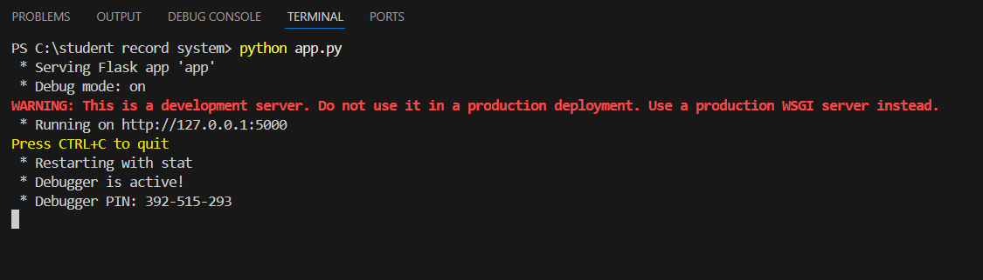
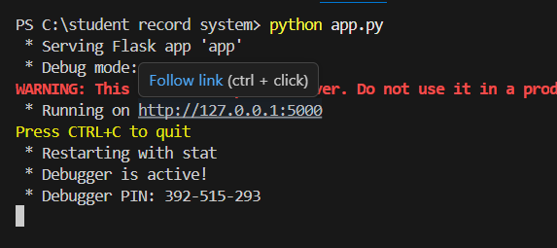
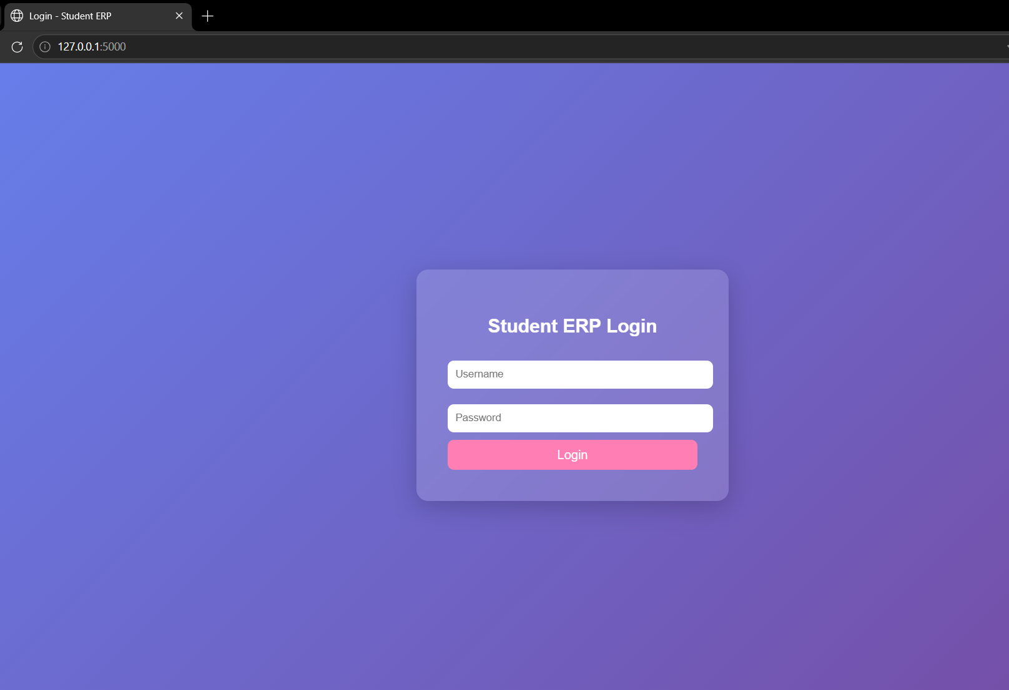

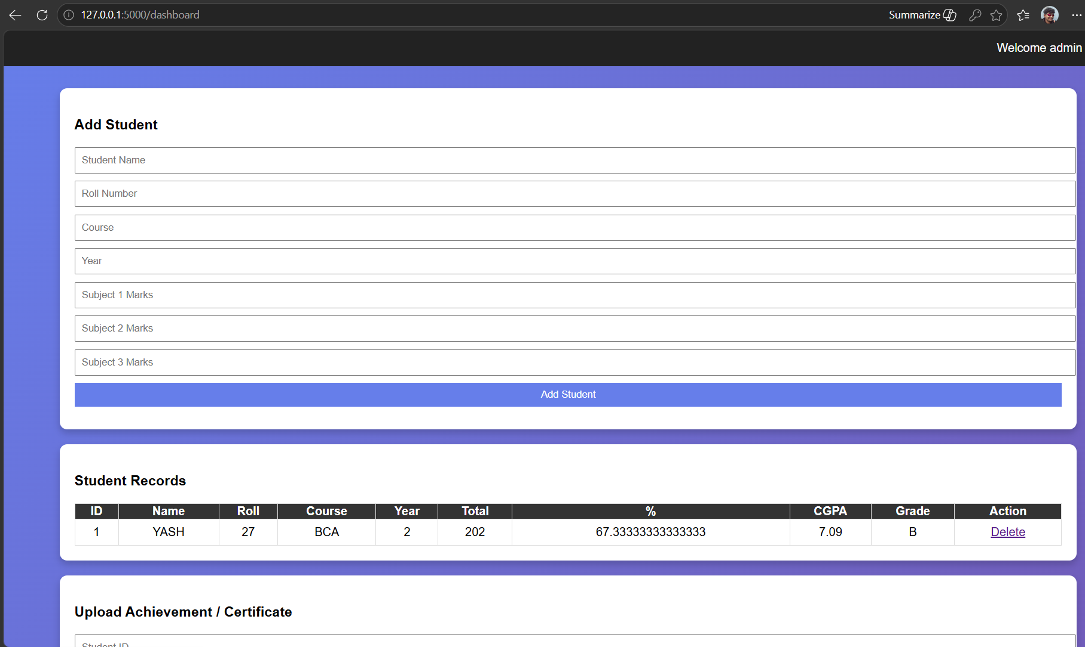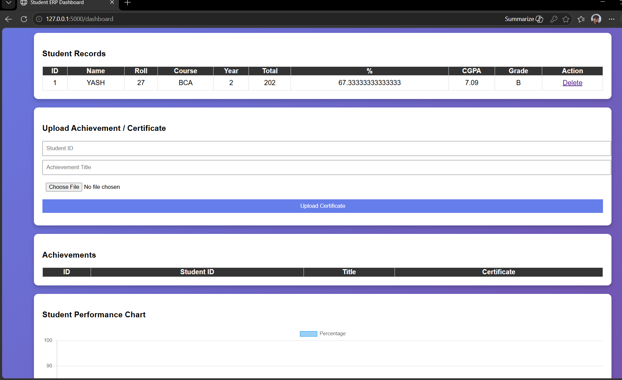

TESTING :-

- Login Testing :- a) Verified Whether the login page opens correctly .
b)Tested vaild Username/ password.
c) Tested invalid credentials.


- Registration/ Data Entry Testing :- a)Checked whether student details can be added.
b)Tested input Fields For proper Data Entry.
c)Verifed record storage .
can see on page number 23

- Record Display Testing :- a)Tested whether saved records are displayed correctlty.
b) verified performance details and data accuracy.
Can see on page number 23
4) Update /delete Testing :- a) Tested updating existing records.
b) Tested deletion functionality.
5) Interface Testing :- a) Checked Button functionality.
b) verified navigation Between pages/ modules.

Future Scope
- Online Student Portal :- In the future, this system can be developed into a complete online student portal where students can view their marks, achievements, certificates, and academic records anytime.
- Mobile Application Integration :- The system can be converted into a mobile application (Android / iOS) so that students and teachers can easily access the platform through their smartphones.
- Advanced Data Analytics :-Future versions can include data analytics and AI-based tools to analysis student performance, identify weak subjects, and predict academic progress.
- Notification System :- The system can include email or SMS notifications to inform students about results, achievements, announcements, or updates.
- Cloud Database Integration :- Instead of a local database, the system can be integrated with cloud databases such as MySQL, Firebase, or AWS for better security, scalability, and remote access.
- Multi-User Access System :- The platform can support multiple user roles such as Admin, Teacher, and Student, each with different permissions and functionalities.
- Certificate Verification System :- A verification system can be added to validate uploaded certificates and achievements, ensuring authenticity and preventing fake records.

Further Enhancements

1) User Role Management :- The system can be enhanced by adding different user roles such as Admin, Teacher, and Student, where each user will have specific access and permissions.
2) Advanced Reporting System :- The project can include detailed reports and dashboards to analysis student performance, subject-wise results, and academic progress.
3) AI-Based Performance Analysis :- Artificial Intelligence and Machine Learning can be integrated to analysis student performance and provide improvement suggestions.
4) Mobile Application Support :- The system can be extended to a mobile application so students and teachers can easily access the platform from their smartphones.
5) Cloud-Based Storage :- The system can be connected to cloud storage and databases for better data security, backup, and accessibility from different locations.
6) Automated Certificate Generation :- The system can automatically generate certificates for achievements and academic performance.
7) Notification and Alert System :- Email or SMS notifications can be added to inform students about new achievements, results, or updates.

Bibliography
- Grinberg, Miguel. Flask Web Development: Developing Web Applications with Python. O'Reilly Media, 2018.
- Beazley, David M., and Brian K. Jones. Python Cookbook. O'Reilly Media, 2013.
- Silberschatz, Abraham, Henry F. Korth, and S. Sudarshan. Database System Concepts. McGraw-Hill Education, 2019.
- Elmasri, Ramez, and Shamkant B. Navathe. Fundamentals of Database Systems. Pearson Education, 2016.
- W3Schools – Web Development Tutorials – Articles and resources on HTML, CSS, JavaScript, and database integration.
URL: https://www.w3schools.com
- Geeks for Geeks – Programming and Computer Science Resources – Tutorials on Python, SQL, –data structures, and web development.
URL: https://www.geeksforgeeks.org
- Python Software Foundation – Python Documentation – Official documentation for Python programming language.
URL: https://docs.python.org
- Flask Documentation – Web Application Framework – Official guide for building web applications using Flask.
URL: https://flask.palletsprojects.com
- SQLite Documentation – Database Management System – Official documentation for SQLite database engine.
URL: https://www.sqlite.org/docs.html
- Chart.js Documentation – JavaScript Chart Library – Guide for creating interactive data visualization charts.
URL: https://www.chartjs.org/docs

